****Measles Self-Administered

Tabletop Exercise

Facilitator/Evaluator Handbook

[Date]

# Exercise Schedule

X:XX am – X:XX am Registration

X:XX am – X:XX am Welcome and Overview of Objectives

* Welcome by [insert agency]
* Introductions
* Ground rules and safety procedures
* Agenda and material review
* Review of TTX Objectives

X:XX am – X:XX am Module 1: Incident Notification and Transport

* Scenario Briefing
* Discussion

X:XX am – X:XX am Break

X:XX am – X:XX am Module 2: Hospital Management

* Scenario Briefing
* Discussion

X:XX pm – X:XX pm Lunch

X:XX pm – X:XX pm Module 3: Patient Monitoring

* Scenario Briefing
* Discussion

X:XX pm – X:XX pm Hot Wash and Conclusion

# Exercise Overview

|  |  |
| --- | --- |
| **Exercise Name** | Measles Self-Administered Tabletop Exercise |
| **Exercise Dates** | [Indicate the start and end dates of the exercise] |
| **Scope** | This exercise is a tabletop exercise, planned for [exercise duration] at [exercise location]. Exercise play is limited to [exercise parameters]. |
| **Mission Area(s)** | Response |
| **Core Capabilities** | [List the core capabilities being exercised] |
| **Objectives** | **Objective 1:** Discuss procedures, capabilities and readiness of the whole community and recognize and respond to presentations by potential infectious disease patients.  **Objective 2:** Review and discuss plans, capabilities, and authorities for responding to a high-risk infectious disease emergency.  **Objective 3:** Examine and demonstrate public notification procedures.  **Objective 4:** Examine and demonstrate public notification and information sharing procedures to address messaging and coordination with stakeholders. |
| **Threat or Hazard** | Measles |
| **Scenario** | After attending a food festival a father and son become extremely ill and are admitted to the hospital. |
| **Sponsor** | Virginia Department of Health |
| **Participating Organizations** | [Insert a brief summary of the total number of participants and participation level (i.e., Federal, State, local, Tribal, non-governmental organizations (NGOs), and/or international agencies). Consider including the full list of participating agencies in Appendix B. Delete Appendix B if not required.] |
| **Point of Contact** | [Insert the name, title, agency, address, phone number, and email address of the primary exercise POC (e.g., exercise director or exercise sponsor)] |

# Preface

The Measles Self-Administered Tabletop Exercise (TTX) is sponsored by [AGENCY NAME]. This Facilitator/Evaluator Handbook was produced with input, advice, and assistance from the Infectious Disease Self-Administered Tabletop Exercise Planning Team, which followed guidance set forth by the U.S. Department of Homeland Security (DHS) Homeland Security Exercise and Evaluation Program (HSEEP).

The Measles Self-Administered Tabletop Facilitator/Evaluator Handbook provides TTX facilitators and evaluators with the necessary tools for their role in the exercise. The exercise and the associated materials and work products are tangible evidence of [AGENCY NAME’S] commitment to ensure public safety through collaborative partnerships that will prepare it to respond to any emergency.

The Measles Self-Administered Tabletop TTX is an unclassified exercise. Some exercise material is intended for the exclusive use of exercise planners, facilitators, and evaluators, but players may view other materials that are necessary to their performance. This document is intended for facilitator and evaluator use only.

All exercise participants should use appropriate guidelines to ensure proper control of information within their areas of expertise and protect this material in accordance with current jurisdictional directives. Public release of exercise materials to third parties is at the discretion of Infectious Disease Self-Administered Tabletop Exercise Planning Team. The F/E Handbook contains detailed information about the duties and responsibilities of exercise facilitators and evaluators.

# Administrative Handling Instructions

1. The title of this document is the *Measles Self-Administered* *Facilitator/Evaluator Handbook.*
2. The material provided in this report contains information that is *For Official Use Only*, or types of sensitive but unclassified information requiring protection against unauthorized disclosure. This document should be safeguarded, handled, transmitted, and stored in accordance with appropriate security directives governing protection and dissemination of such information. Reproduction of this document, in whole or in part, without prior approval from [Agency Name] is prohibited.
3. At a minimum, the attached materials will be disseminated only on a need-to-know basis and, when unattended, will be stored in a locked container or area offering sufficient protection against theft, compromise, inadvertent access, and unauthorized disclosure.
4. Exercise Planning Point of Contact:

Exercise Director

[Name]

[Title]

[Phone]

[Email]

**Table of Contents**

Exercise Schedule 1

Exercise Overview 2

Preface 4

Administrative Handling Instructions 5

General Information 7

Introduction 7

Confidentiality 7

Objectives and Core Capabilities 8

Table 1. Exercise Objectives and Associated Core Capabilities 9

Assumptions 9

Exercise Participants 9

Exercise Structure 10

Exercise Ground Rules 10

Exercise Guidelines 11

Exercise Modules 11

Exercise Control 11

Exercise Facilitation 12

Exercise Evaluation 13

Evaluator Instructions and Guidelines 17

Assessment, Review, and Analysis of Exercise 20

Sample Briefing 24

Appendix A: Exercise Schedule 37

Appendix B: Records and Forms 1

Appendix C: Acronyms 1

Appendix D: Sample Exercise Evaluation Guides 1

# General Information

## Introduction

The Measles Self-Administered Tabletop Exercise (TTX) is designed to establish a learning environment for players to exercise emergency response plans, policies, and procedures as they pertain to response and recovery from multiple threats and hazards associated with a Measles outbreak. To ensure an effective exercise, subject matter experts (SMEs) and representatives from numerous State and Local agencies, and private sector have taken part in the planning process and will participate in the exercise conduct and evaluation.

This F/E Handbook was produced at the direction of VDEM with input, advice, and assistance from the Infectious Disease Self-Administered TTX Exercise Planning Team.

## Confidentiality

The Measles Self-Administered TTX is an unclassified exercise. Control of exercise information is based on public sensitivity regarding the nature of the exercise rather than the actual exercise content. Some exercise material is intended for the exclusive use of exercise planners, controllers, simulators, and evaluators, but players may view other materials deemed necessary to their performance.

All exercise participants should use appropriate guidelines to ensure the proper control of information within their areas of expertise and protect this material in accordance with current VDEM directives.

Any inquiries concerning the authorized use of this document or any other exercise-related materials should be directed to [whom] and/or the exercise planning team primary point of contact.

### Purpose

The purpose of the VDEM sponsored Measles Self-Administered TTX is to provide participants with an opportunity to evaluate current response concepts, plans, and capabilities for a response to Measles in [NAME OF COUNTY], Virginia. The goal is for participants to validate coordination and communications capabilities for all-hazard incidents, verify policies and procedures for responding to infectious disease outbreaks, and to identify the overall strengths and weaknesses of emergency plans. This will be done through an open discussion between local, state and private sector partners.

### Scope

The Measles Self-Administered TTX is to run ___ hours and will include [emergency managers, local government officials, law enforcement, state partners, regional partners, private sector and non-governmental agencies from _______].

### Format

Exercise facilitators are able to select from one of five infectious diseases scenarios. Each scenario presents similar issues that health officials will need to work through. Before administering the exercise, facilitators should review each scenario and select which is most appropriate for their group. Once a scenario is selected, the facilitator will review the Situation Manual (SitMan), Exercise Briefing Slides, Exercise Evaluation Guides, and Participant Feedback Forms and begin filling in the blue and gray text to customize the information to their locality.

The scenarios can also be adjusted for difficulty by changing certain scenario elements such as number of persons affected or by incorporating elements into the document that are in the gray “Instructor Notes” box throughout this document. These scenarios should be adjusted to fit the needs of your locality and can be dialed up or down as needed.

The discussion questions listed in the SitMan are supposed to provide a tasting of potential questions that could be asked. Additional questions are listed under the main discussion questions in the SitMan.

## Objectives and Core Capabilities

The U.S. Department of Homeland Security (DHS) and the Centers for Disease Control and Prevention (CDC) have adopted capabilities-based planning and exercises as a means of achieving the National Preparedness Goal (NPG). Resource allocation will be linked to capabilities that are most urgently needed for a wide range of assigned missions and tasks.

Exercise objectives focus on improving understanding of a response concept, identifying opportunities or problems, and achieving a change in attitude. They are directly tied to Core Capabilities in five national preparedness mission areas: Prevention, Protection, Mitigation, Response, and Recovery. These five mission areas, which are highly interdependent and applicable to any threat or hazard, exist along a continuum; there is dynamic interplay among them and even some commonality in the core capabilities essential to each.

Each core capability includes capability targets for which measures will be developed. The core capabilities and capability targets are not exclusive to any single level of government or organization, but rather require the combined efforts of the whole community.

The Measles Self-Administered TTX is a capabilities-based exercise. The exercise objectives have been selected by the exercise planning team. The objectives focus on improving our understanding of a regional response concept, identifying opportunities, issues or problems, and enhancing our response capabilities to a Measles outbreak.

The following exercise objectives in Table 1 describe the expected outcomes for the exercise. The objectives should be linked to core capabilities from DHS or CDC depending on the evaluation needs of the Exercise Planning Team.

| Exercise Objective | Core Capability |
| --- | --- |
| **Objective 1** – Discuss procedures, capabilities and readiness of the whole community and recognize and respond to presentations by potential infectious disease patients. | INCLUDE NAME AND FULL DEFINITION OF CORE CAPABILITY |
| **Objective 2** – Review and discuss plans, capabilities, and authorities for responding to a high-risk infectious disease emergency. | INCLUDE NAME AND FULL DEFINITION OF CORE CAPABILITY |
| **Objective 3** – Examine and demonstrate public notification procedures. | INCLUDE NAME AND FULL DEFINITION OF CORE CAPABILITY |
| **Objective 4** – Examine and demonstrate public notification and information sharing procedures to address messaging and coordination with stakeholders. | INCLUDE NAME AND FULL DEFINITION OF CORE CAPABILITY |

Table 1. Exercise Objectives and Associated Core Capabilities

## Assumptions

Assumptions establish a realistic foundation for the exercise and are therefore present before the start of the exercise. The following general assumptions apply to the exercise:

* The exercise will be conducted in a no-fault learning environment, in which plans, policies, and processes—not individuals—are evaluated.
* The exercise scenario will be realistic and plausible, and containing sufficient detail for an effective tabletop discussion.
* Exercise players will react to the information and situations as they are presented, and respond to the incident scenario in the same manner as if this were a real event.

## Exercise Participants

The term participant encompasses many groups of people, not just those playing in the exercise. Categories of participants and exercise locations involved in the exercise are as follows:

* **Players** respond to the situation presented, based on expert knowledge of response procedures, current plans and procedures, and insights derived from training.
* **Facilitators** provide situation updates and moderate discussions. They also provide additional information or resolve questions as required. Key Exercise Planning Team members also may assist with facilitation as subject matter experts (SMEs) during the TTX.
* **Evaluators** observe the exercise and take notes. Their observations on the strengths and weaknesses of the players’ agencies will be used to populate the After Action Report and Improvement Plan.
* **Observers** visit or view selected segments of the exercise. They do not play in the exercise, and do not perform any control or evaluation functions. They will view the exercise from a designated observation area and will be asked to remain in the observation area during the exercise. VIPs are also observers, but they are frequently grouped separately. A dedicated group of exercise controllers will be assigned to manage these groups.
* **Support staff** members include individuals assigned administrative and logistical support tasks during the exercise (e.g., registration, credentialing, catering).

## Exercise Structure

This TTX will be a multimedia-supported, facilitated discussion. As the scenario is presented, participants review the situation and engage in discussions of appropriate response issues.

## Exercise Ground Rules

The following exercise ground rules have been developed to ensure that the objectives are met in a reasonable amount of time and that the TTX runs smoothly.

* Keep the Exercise’s Objectives in mind throughout the exercise.
* Treat the scenario incidents as real events. Play your appropriate role.
* Participate openly and focus discussions on appropriate topics. Asking questions, sharing thoughts, and offering forward-looking, problem-solving suggestions is strongly encouraged, as these actions will enhance the exercise experience.
* Keep your comments focused and consider the time constraints. The discussions will explore policies, decisions, actions, and key relevant issues, which will require participants to respect the observations, opinions and perspectives of others.
* Issues and procedures flowing from each module presented will be discussed.
* After reviewing each scenario, participants will have approximately 5 minutes to individually consider the appropriate processes, decisions, and courses of action. Following this, a facilitated general discussion of response issues and actions related to this scenario will be conducted.

## Exercise Guidelines

* This TTX will be held in an open, low-stress, no-fault environment. Varying viewpoints, even disagreements, are expected.
* Participate based on your knowledge of current plans and capabilities (i.e., you may use only existing assets) and insights derived from your training.
* Decisions are not precedent setting and may not reflect your organization’s final position on a given issue. This exercise is an opportunity to discuss and present multiple options and possible solutions.
* Issue identification is not as valuable as suggestions and recommended actions that could improve response and preparedness efforts. Problem-solving efforts should be the focus.
* The situation updates, written material, and resources serve as the basis for discussion.
* Assume cooperation and support from other responders and agencies.

## Exercise Modules

The TTX is composed of three modules representing unique scenario information regarding an Measles outbreak. During the course of each module, participants will be expected to discuss preparedness, prevention, response and recovery actions for the scenario event. Each module consists of a scenario briefing and facilitated discussions.

## Exercise Control

The exercise will be controlled and guided by the facilitator. The facilitated TTX uses a scenario-based approach to create the decision-making environment for participants to act in their potential operational roles. This is a no-fault exercise that focuses on the identification and analysis of issues of common concern.

During the TTX, an objective facilitator will lead participants through the activities surrounding the scenarios. The facilitator is responsible for keeping discussions on track with exercise objectives and ensuring that all issues are explored (time permitting). In general, the facilitator will:

* Keep side conversations to a minimum; keep discussions on track and within established time limits; control group dynamics and strong personalities; and speak competently and confidently about the subject at hand. The facilitator will not dominate the conversation.
* Possess subject matter expertise relevant to the issues presented in the exercise.
* Be aware of local plans and procedures.

Scenario briefings will be given at the beginning of each module. Each module presents a unique timeframe within the scenario that will focus on validating capabilities and discussing preparedness, prevention, response and recovery activities. Each briefing will be accompanied by a visual presentation, which will provide participants the situation updates for the period of time including impacts, damage information, as well as preparedness, prevention, response, and/or recovery activities occurring for that period.

After each presentation, the facilitator will solicit discussion on key activities and decisions that individuals or organizations would perform in the specific scenario time period. Throughout the exercise, the facilitator will press organizations to discuss their biggest challenges and make commitments on how those challenges can be addressed.

## Exercise Facilitation

Facilitators set expectations for the exercise by addressing participants, introducing and presenting the various modules, leading discussion, and coordinating issues between groups. The facilitator focuses the group’s discussions on specific areas and questions, elicits resolutions to issues, and prepares notes on the group’s discussions.

A facilitator should be comfortable talking in front of large groups of people, and should be comfortable managing and guiding a group. Facilitators typically come from the Exercise Planning Team, participating agencies, and neighboring jurisdictions. Facilitator training addressing responsibilities, preparation, exercise specific objectives and scenario can occur the day before or the day of the exercise.

Each participant will be provided with a Situation Manual (SitMan), which includes a Participant Notes Sheet and Participant Feedback Form. At the beginning of the discussion period, introduce yourself and have the participants at the table introduce themselves.

The Participant Feedback Form will be completed at the end of the session (or players may make notes as the exercise proceeds). *This form will be turned in at the end of the exercise.*

**Tips for Facilitation**

* Adequate preparation is the best safeguard against serious problems. Do not assume that because you have facilitated before, preparation is unnecessary.
* Understand what the group expects of you, and let them know what you expect of them.
* Be flexible. Have alternative ideas on how to achieve exercise goals.
* There are no wrong answers. Always respond in a positive manner, such as, “That’s an interesting perspective. Would anyone like to comment on it?”
* Do not be too serious when you confront a problem. A little humor can make the situation much easier to handle. Try to anticipate problems you might have.
* Make sure the group understands that you all share responsibility for the success or failure of the session.
* Be honest at all times. If you do not know an answer, say so, then try to find it.
* If available, review the applicable plans, policies, and procedures to ensure a basic understanding of the system and potential issues that may arise.
* Review and understand the exercise objectives; these are your guidelines for facilitating the group and keeping it on track. Review this Facilitator/Evaluator (F/E) Handbook and its reference documents to plan how to help the group attain the exercise goals.
* Develop a personal strategy for facilitating the group. Use information provided and prior experience to prepare supplemental questions to guide the flow of discussion and augment the specific questions in this handbook.

## Exercise Evaluation

Exercise evaluation is an essential element of a successful exercise program. A good evaluation is part of a progressive exercise program where exercises are planned, conducted, and evaluated as building blocks to competency in incident management for the long–term.

The evaluation portion of the exercise program is aligned with the established program metrics. During the TTX, an Evaluation Team will be listening for themes in discussion and issues. These issues will then be reviewed during the Hot Wash. Lessons learned during the exercise will allow participants to update their current response plans and strategies as needed.

Evaluations provide an objective assessment of the participants’ discussions. They have been designed to support an assessment of exercise objectives and capabilities. The goal of evaluation is to validate strengths and identify opportunities for improvement among participating organizations. Evaluations help to identify ways to build on strengths and improve capability. The evaluation methodology for this TTX focuses on the adequacy of and familiarity with the jurisdiction’s plans, policies, procedures, resources, and interagency/inter-jurisdictional relationships that support the performance of critical tasks required to respond to a Measles outbreak. Validation attempts to answer the following questions:

* Were established plans, policies, procedures, and protocols followed during the exercise?
* Did the agencies do what they said they were going to do?
* Were the plans, procedures, and protocols effective?
* What level of capability do the plans, policies, and procedures establish?

This validation is accomplished by the following means:

* Observing the event and collecting supporting data.
* Analyzing the data to compare performance against objectives and expected outcomes.
* Determining what changes need to be made to procedures, plans, staffing, equipment, communications, organizations, and interagency coordination to ensure expected outcomes.

The evaluation results will provide an opportunity to identify ways to build on strengths and areas to improve capabilities. Since jurisdictions are testing new and emerging plans, skills, resources, and relationships in response to a changed homeland security environment, every exercise or event can be expected to result in multiple findings and recommendations for improvement.

The Measles Self-Administered TTX uses EEGs formulated by the DHS and evaluation methodologies established in the HSEEP as the guide for conducting all exercise evaluation. The AAR/IP will be formatted so that it conforms to current DHS guidance.

**After-Action Report and Improvement Plan (AAR/IP) –** The AAR/IP will be organized by capability, with a section of the AAR/IP devoted to each of the exercised capabilities. For each capability and subordinate activity, the Lead Evaluator will provide an assessment of how well the executing agency or personnel performed, including best practices and areas for improvement. Specific issues and observations will be identified for each capability and activity, and recommendations for resolving issues will be provided, based on input from controllers, evaluators, and exercise planners.

**Exercise Evaluation Guides (EEGs) –** The content for the AAR/IP will be drawn from the EEGs. Each evaluator will be provided with an EEG that will give specific guidance regarding what data to collect during the exercise, how to record it, and how to analyze it before submission to the Lead Evaluator. The Lead Evaluator will compile all evaluator submissions into the first working draft of the AAR/IP.

Each EEG provides a list of subordinate activities and tasks that players are expected to perform during the exercise to demonstrate the specified capability. These tasks will be divided into organizational capability targets and critical tasks. The EEGs for this exercise can be found in Appendix D.

**Evaluator Responsibilities –** Player performance must be observed and analyzed against plans, policies, procedures, and practices, using criteria established before the exercise. Evaluators document player performance by using EEGs and information obtained during the Hot Wash. The evaluations, documentation, Hot Wash, and debriefing discussion(s) provide important information that substantiates exercise conduct and performance. The AAR/IP will summarize the overall results of the exercise and provide a comprehensive assessment of capabilities and plans that were demonstrated.

The ultimate goal of the exercise evaluation process is to ascertain whether or not there are shortcomings within the emergency plans and organizations being exercised. As such, Evaluators should be trained and thoroughly prepared for their assigned duties. Understanding the scope, exercise objectives, and evaluation criteria, and being familiar with the emergency plans and implementation procedures will help ensure accurate documentation of participant actions. Specific evaluator activities include the following.

**Before the Exercise**

* Review appropriate plans, policies, procedures, and protocols.
* Attend required evaluator training and other briefings.
* Review appropriate exercise materials, including the exercise schedule and evaluator instructions. Become familiar with the exercise objectives, scenario for discussion, key evaluation areas, and Exercise Evaluation Guide (EEG) contents.
* Review the EEGs and other supporting materials for your area of responsibility.
* Report to the exercise check-in location at the time designated in the exercise schedule, and meet with the exercise staff.
* Be at the appropriate location before the exercise starts.

**During the Exercise**

* Wear controller identification items (i.e., badge and vest). Evaluator badges will be issued at exercise registration on [ENTER DATE].
* Avoid personal conversations with exercise players.
* Do not focus on filling out the EEG analysis forms; rather, listen closely to the participants’ discussions and take detailed notes relative to your assigned area of evaluation. You should be familiar with the activities and tasks for evaluation, but do not jump ahead to analysis until the exercise has ended.
* Do not prompt players with specific responses or interfere with player performance in any way.
* Your primary duty is to document player performance; observe and record the particular activity or conduct. After the exercise, that information will be used to determine whether the exercised capabilities and plans were effectively implemented or demonstrated and to identify strengths and improvement items.
* Compare the activities and conduct against exercise objectives.
* Note strengths and areas for improvement as well as other observations of that activity.

**After the Exercise**

* Use your EEGs to help organize your notes in categorized data for use in the After Action Report (AAR). The EEGs list all of the critical tasks that should have been discussed, based on exercise objectives. As you complete the forms, you will identify strengths and areas for improvement for each task.
* Participate in the Hot Wash, and take notes on findings identified by players. Before the Hot Wash, do not discuss specific issues or problems with participants.
* After the Hot Wash, summarize your notes and prepare for the Facilitator and Evaluator Debriefing and Evaluator Workshop. Have your summary ready for the Lead Evaluator. Complete all the information required by the EEGs and submit an electronic copy of your forms to the Lead Evaluator.

**Documenting the Event –** Evaluators must keep accurate records and notes because these records will form the basis for evaluation of player performance. Evaluation is valuable because it provides constructive feedback (positive and negative) to improve the effectiveness of an organization’s response to emergencies. Accurate and detailed documentation is critical to facilitate a full record of all the events in an exercise and to understand player actions.

Evaluators will document the exercise by using the appropriate EEGs for actions in their area. The EEGs are provided separately as part of the evaluator package. Evaluators should document key activities and those activities that require a timely response for later evaluation.

Evaluators should review their forms and notes immediately after the exercise to ensure an accurate reconstruction of events and activities for discussion at the Facilitator and Evaluator Debriefing. Evaluation materials, including notes and forms, become part of the exercise documentation. Checklists and evaluation forms must be completed as thoroughly and accurately as possible.

**Evaluator Package –** Evaluators will receive their materials for review at the Facilitator and Evaluator Briefing or exercise registration. Electronic copies of exercise materials will be provided prior to the exercise. The evaluator package contains this F/E Handbook, the SITMAN, EEGs, and other items as necessary. Evaluators should bring the package to the exercise. They may reorganize the material so information that is critical to their specific assignment is readily accessible. Evaluators may bring additional professional materials specific to their assigned activities.

**Evaluator Training Webinar and Evaluator Briefing –** These briefings will assist in preparing evaluators for performance of their functions and will include a detailed review of event activities. These briefings are the time for evaluators to ask questions and ensure that they completely understand their roles and responsibilities. Evaluator questions should be addressed and information clarified so that controllers and evaluators feel confident that they can perform their assignments effectively.

## Evaluator Instructions and Guidelines

**General –** Evaluators should avoid personal conversations with players. Evaluators should not give information to players about event progress or other participants’ methods of problem resolution. Players are expected to obtain information through their own resources.

**Evaluation Basics –** Remember, your experience and expertise are your most important tools. Experienced evaluators use the following techniques for effective evaluation:

* Use EEGs to confirm that evaluation objectives are met.
* Take detailed notes concerning significant activities observed, including the time they were initiated or completed.
* When more than one evaluator is assigned to an area, divide responsibilities to ensure detailed evaluation of player activities.
* Stay in proximity to player decision makers.
* Focus on critical tasks, as specified in the EEGs.

**Recording Important Events –** Although numerous events may occur simultaneously, evaluators do not need to record all the action. Knowing which events are important helps evaluators eliminate superfluous data and provide the kind of information that is most useful for evaluation. Important events that evaluators should record include the following:

* Initiating scenario events.
* Actions of players in relation to the event.
* Key decisions made by managers and the times these decisions are made.
* Deviations from plans and implementation procedures.
* Times when significant actions are completed.
* Equipment used.

**What to Look For –** Knowing which events are important makes recording the action manageable, eliminates superfluous information, and provides the kind of data most useful for exercise evaluation. The important information evaluators should record are the discussions relating to the exercise objectives.

Other items to record include:

* Deviations from plans and implementation procedures.
* Roles and responsibilities.
* Decisions.
* Information sharing.
* Mutual agreements.
* Recommendations.
* Unresolved issues.

**Analyze Data –** The goal of data analysis is to assess performance by identifying issues that were discussed, resolutions that were reached, and/or problems that remained outstanding. The analysis phase takes place primarily at the F/E debriefing, which follows the Exercise. This debriefing serves as an opportunity to compare notes and begin the process of root cause analysis. Activities expected to occur at this meeting include the clarification of discussion points, verification and comparison of reports, and agreement about how the various issues that arose related to the identified objectives. The goal of the meeting is to emerge with a list of issues for inclusion in the AAR, as well as recommendations for improvement.

**DURING ANALYSIS, ANSWER THE FOLLOWING QUESTIONS:**

* *What happened?* What the observation team actually saw and supporting documentation.
* *What was supposed to happen?* Based on the plans and procedures.
* *Was there a difference and why?* Conduct a root cause analysis of why.
* *What was the impact?* Were the consequences of the action (or inaction, or decision) positive, negative, or neutral?
* *What should be learned and what are the recommendations for improvements?* The fixes to the root cause.

**Determine the Root Causes of Differences –** Facilitators and evaluators should be able to identify where the participants identified gaps or deficiencies and areas of strengths in the policies, procedures, or decision-making processes as related to the objectives. Questions to consider include the following:

* Did the players’ actions reveal innovative solutions to problems that should be shared?
* Is the current status of the policies, procedures, organizational structure, etc., adequate to meet the needs if a real emergency of this nature occurred? If not:
  + What aspects are deficient?
  + What would be the consequences of the deficiency on the response, recovery, and protection of the public?
  + Why do these deficiencies exist (i.e., previously unidentified, lack of funding)?

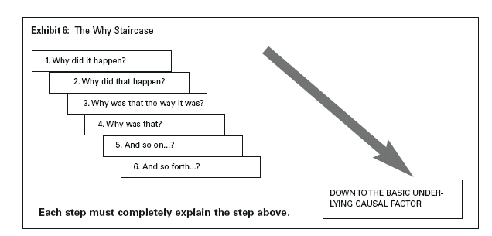Facilitators and evaluators should then search for the root cause of why a deficiency exists or why an incorrect decision was made. The analysis team should keep asking why until the root cause is found. It is important to reach this level of understanding to make recommendations to enhance preparedness.

**Identify Opportunities for Improvement –** The identification of issues, and their root causes, enables the evaluators to develop recommendations for improvement. The recommendations should state what steps should be taken to improve and who should complete these steps. These recommendations should have enough detail to make them useful. Recommendations such as “train on alert and warning process” do not help the response community. However, a recommendation indicating that “the 24‑hour warning point staff needs additional training on reading siren system printouts so they can better identify system failures” focuses on a root cause. Sometimes, it is not clear exactly what steps should be taken (e.g., no resources exist to purchase new equipment) or who should complete these steps (e.g., coordination is an issue). In these cases, the evaluators may recommend that the pertinent agency director appoint a task force to address the issue.

Evaluators should use the following questions as a guide for developing recommendations for improvement:

* What changes need to be made to organizational structures to improve performance?
* What changes need to be made to plans and procedures to improve performance?
* What changes need to be made to leadership and management processes to improve performance?
* What training is needed to improve performance?
* What changes to (or additional) equipment are needed to improve performance?

In identifying recommendations, evaluators need to focus on who will be responsible for carrying out the action, which will depend on whether the recommendation is aimed at the individual, functional, or agency level.

**Placement and Monitoring –** Evaluators should be located so they can observe player actions and hear conversations without interfering with those activities. In certain conditions, more than one evaluator may be needed in a particular setting or area.

**Post-Exercise Activities –** The Lead Evaluator will notify you when evaluation of the event has been suspended or terminated. The evaluation will be terminated when the Exercise Director determines that all exercise objectives have been met or enough time has elapsed for exercise objectives to have been demonstrated.

All evaluators are expected to participate in a Hot Wash and take notes on findings identified by players. Before the Hot Wash, evaluators should not discuss specific issues or problems with participants. After the Hot Wash, summarize your notes and prepare for the Facilitator and Evaluator Debriefing. Have your summary ready for the Lead Evaluator.

## Assessment, Review, and Analysis of Exercise

**Hot Wash** –Immediately following exercise play, facilitators will facilitate a Hot Wash with players at their assigned location. The Hot Wash is an opportunity for players to voice their opinions on the exercise and their own performance. At this time, evaluators can also seek clarification on certain actions and what prompted players to take them. The Hot Wash should not last more than 30 minutes. Evaluators should take notes during the Hot Wash and include these observations in their analysis.

**Facilitator and Evaluator Debriefing and Evaluator Workshop** –Facilitators, evaluators, and selected exercise participants will attend a facilitated F/E debriefing following exercise play. During the debriefing, they will discuss their observations of the exercise in an open environment to clarify the actions taken. Following the briefing, Evaluators will participate in a workshop to complete their EEGs and evaluation write-ups for submission to the Lead Evaluator, and begin the analysis process outlining the issues to be included in the After-Action Report (AAR).

**Evaluation Write-up** –There are several steps involved in developing an effective evaluation write-up. Although there is no required length for your write-up, the average length is a several paragraphs to a page. In order for the AAR to be prepared properly, it is essential that information be submitted using the process and format outlined. You will find a sample evaluation write-up format you can use to complete your write-ups for inclusion on your EEG below. **All EEGs and evaluator write-ups are due to [LEAD EVALUATOR] at [EMAIL ADDRESS] by [DATE].**

**Issue Write-up Structure**

Use the EEG in Appendix E to identify and complete the following components for the evaluation.

**Organizational Capability Targets:** A group of critical tasks tied to a core capability.

**Critical Tasks:** Look at each critical task described for the organizational capability in the EEG.

**Observation Notes and Explanation of Rating:** Include the strengths, areas for improvement, and root cause analysis for each critical task.

* **Strength/s:** A strength is an observed action, behavior, procedure, and/or practice that is worthy of recognition and special notice.
* **Area/s for Improvement:** Areas for improvement are those areas in which the evaluator observed that a necessary task was not performed or that a task was performed with notable problems.
* **Root-Cause Analysis:** When completing the analysis, evaluators should consider the following:
* Observations: What happened?
* Were the capability targets met? If the targets were not met, what factors contributed to this result?
* Did discussion or activities suggest the critical tasks were executed to meet capability targets? If not, what were the impacts or consequences?
* Do current plans, policies, and procedures support critical tasks and capability targets? Were participants familiar with these documents?
* Root-Cause: The source of or underlying reason behind an identified issue toward which the evaluator can direct an improvement.
* Suggested corrective action/s.

**Target Rating:** Assign a target rating for each organizational capability target based on this ratings key:

|  |  |
| --- | --- |
| Ratings Key | |
| P | Performed without Challenges |
| S | Performed with Some Challenges |
| M | Performed with Major Challenges |
| U | Unable to be Performed |

**Participant Feedback Forms** –Participant Feedback Forms will be used to document participant information about the exercise. The facilitator will distribute these forms to exercise participants at the Hot Wash. The forms will be collected afterward, along with attendance or participation rosters. Facilitators should emphasize to players that these forms provide the opportunity for them to comment candidly on emergency response activities and exercise effectiveness.

**After Action Report Meeting** –The After Action Report Meeting is a forum for jurisdiction and organization officials to hear the results of the evaluation analysis, validate findings and recommendations in the draft After Action Report (AAR), and begin development of the Improvement Plan (IP). The IP identifies how recommendations will be addressed, including what actions will be taken, who is responsible, and the timeline for completion.

**Exercise Report** –An exercise AAR/IP will be prepared to document the evaluation of overall exercise performance. The AAR/IP will include the exercise schedule, scenario, players’ activities, evaluations, issues, opportunities, and best practices. The AAR will also contain the following:

* A brief summary, with introductory and general statements noting the exercise scope, purpose, objectives, players, and overall performance assessment.
* Assessments for each capability observed.
* Issues and recommendations suggested by controller, evaluator, and player comments.

A draft AAR will be provided to participating organizations for comment before the After Action Report Meeting is held.

THIS PAGE IS INTENTIONALLY LEFT BLANK

# Sample Briefing

The briefing presents the scenario information to the players. It contains the same information that is in the Situation Manuals in condensed form. The slides for this exercise are below, with suggested remarks and discussion prompts for the facilitator to use when presenting the slides to exercise participants.

The first slide, or “cover slide”, presents the sponsoring agency or jurisdiction and exercise name.

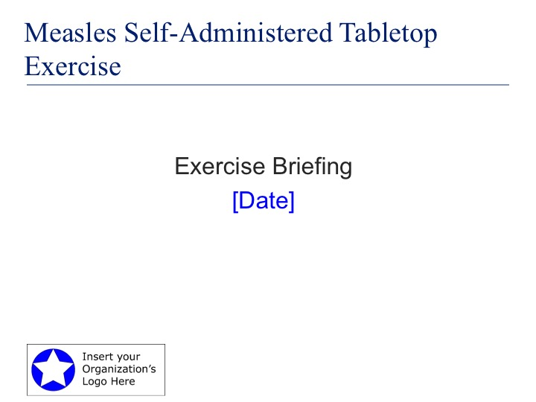

At the start of the exercise, the facilitator should call the assembled participants to order and introduce him/herself to them. He or she should then have participants introduce themselves to the group by stating their name and the agency or organization they are representing. Even if an attendee is only observing the exercise, he or she should still introduce himself or herself so that all attendees are aware of which entities are being represented. The facilitator should also take a moment to thank the participants for attending. The development of this exercise was sponsored by [insert agency] for use by local health departments and emergency management agencies. This TTX is intended to prompt discussion of health response capabilities and procedures at the local level, including command and control issues, so that local partners can identify strengths and areas for improvement.

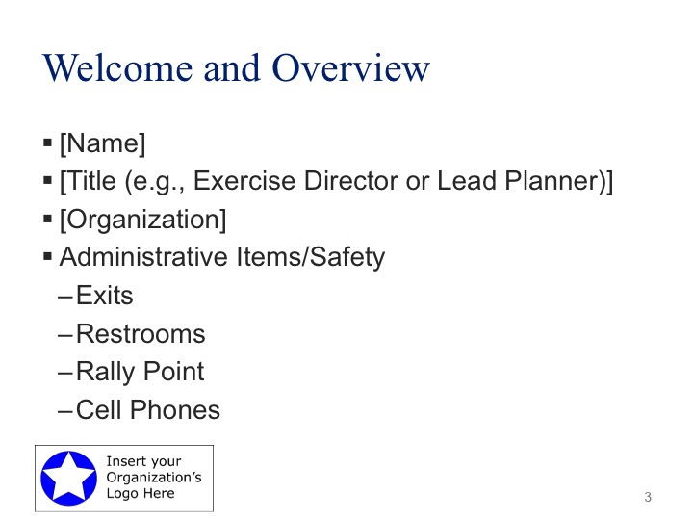

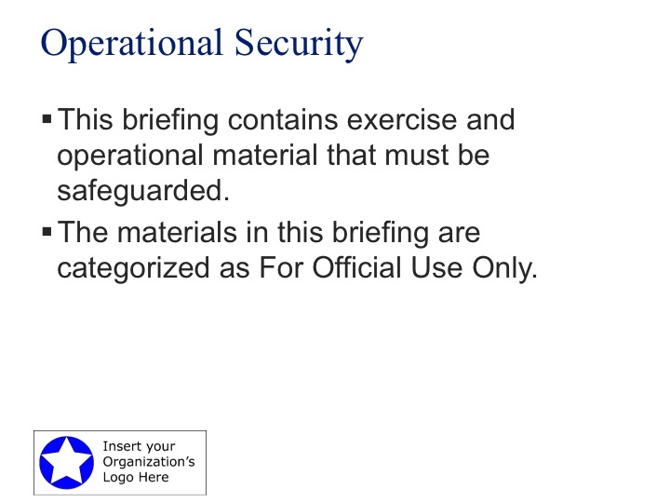

The next slide contains the exercise schedule. This outlines the estimated timeline for exercise conduct. Briefly run through the information for the participants.

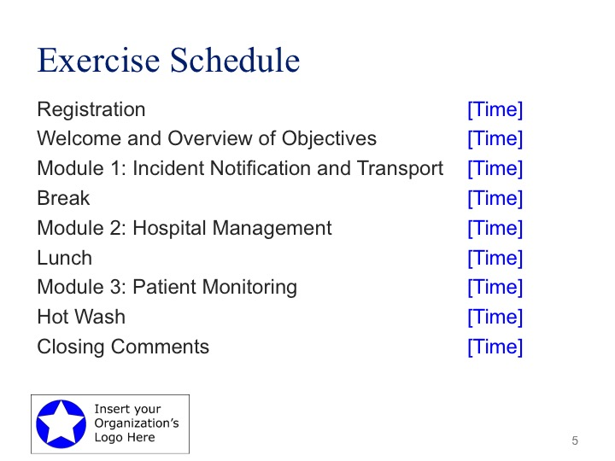

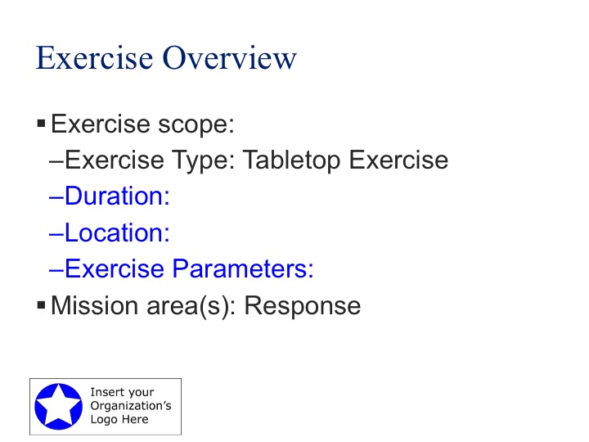

The next slide describes the scope of the exercise. It has a short, broad statement of purpose of the TTX. Read this statement for the participants and give them the opportunity to comment or ask questions on the scope of the TTX.

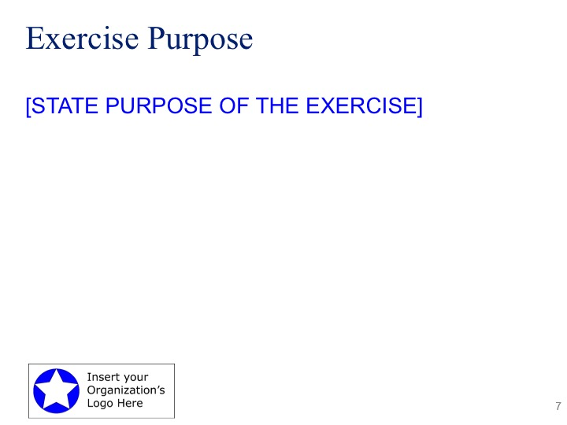

The following slide highlights the objectives and core capabilities. The attendees will have this information in their Situation Manuals. The facilitator should take the time to be sure that participants understand the objectives. Each exercise team will determine which Core Capabilities are being tested during this exercise. Be sure to fill in the “Aligns to” portion with the capabilities being observed for this exercise.

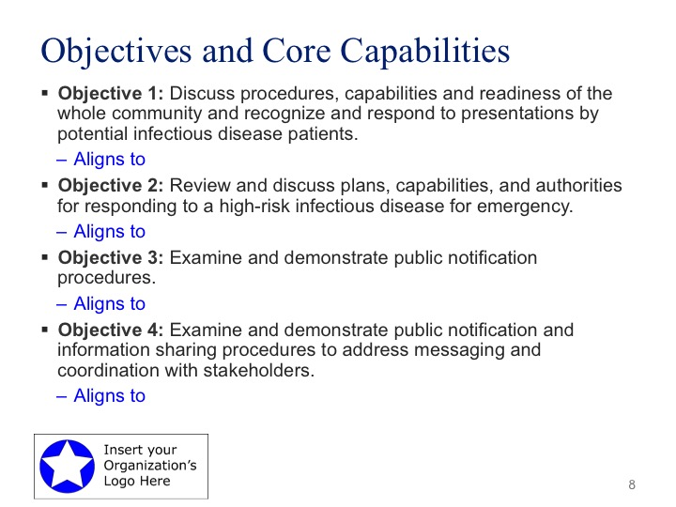

The next three slides contain general information about the process and format of a TTX. Again, the players will have this information in greater detail in their Situation Manuals, but the facilitator should go over it briefly in order to be sure that all players understand their roles and the process of a TTX.

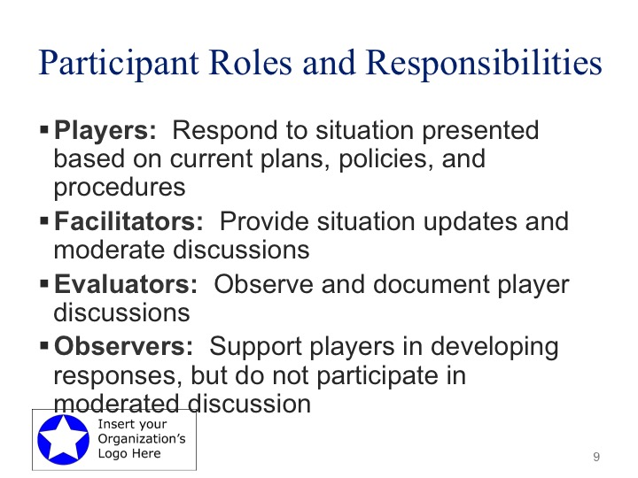

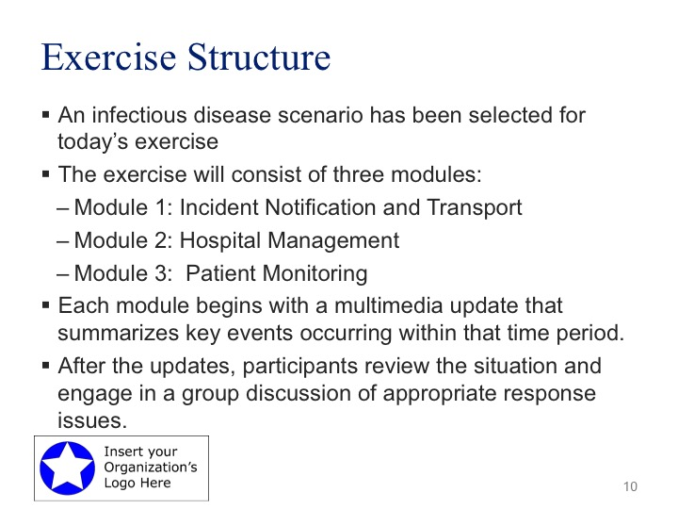

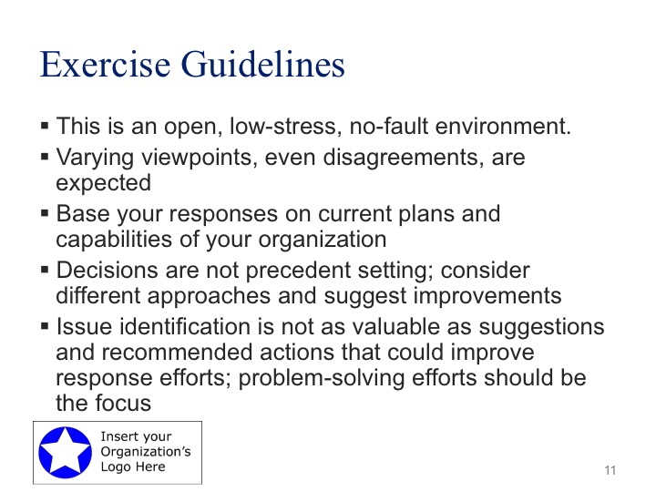

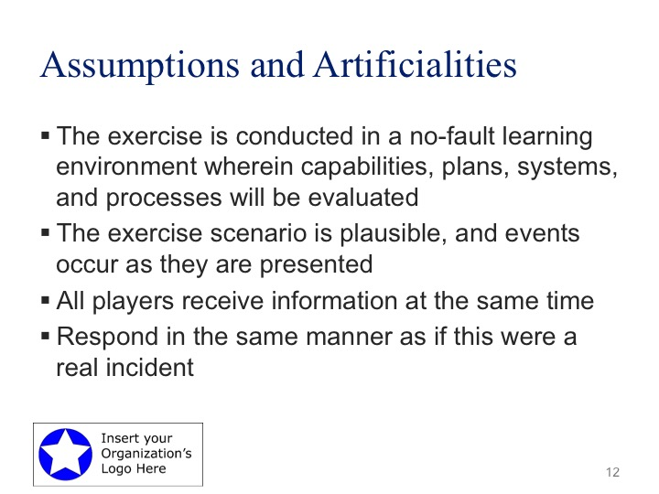

The following slides present the basic scenario elements and set the scene for the exercise.

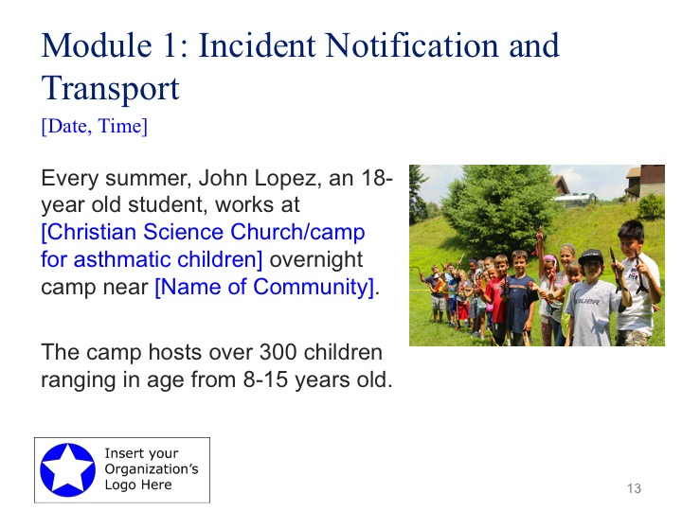

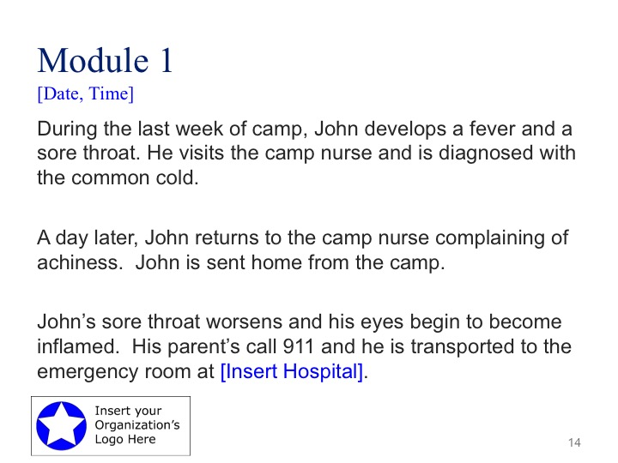

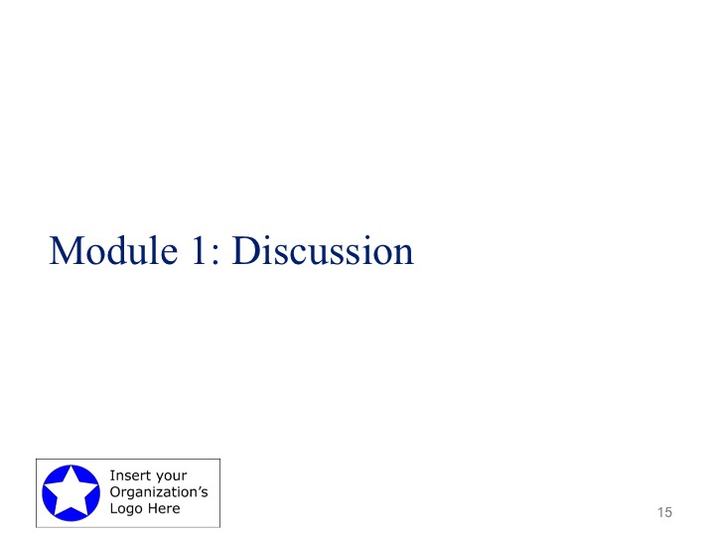

***Instructors Note: Religious undertones can be removed and traded for a camp for asthmatic children or other vulnerable populations. Symptoms could escalate faster and he could present a rash on his forehead.***

Suggested Questions for each module are also provided in the Situation Manual.

**Suggested Questions:**

**911 Dispatch or Emergency Medical Dispatch**

1. What, if any, are any immediate concerns of the 911 Dispatcher?
2. What, if any, current protocols or procedures exist to help the dispatcher make a determination regarding the potential threat of an infectious disease? Is this a warranted consideration?
3. What trainings are or should be available for Dispatch staff on proper infectious disease reporting/dispatch procedures?
4. What (if any) symptom-related questions could call takers ask?

**EMS**

1. First symptoms mimic cold of flu symptoms, what other questions might a provider ask to further identify the disease?
2. How would the transport of this patient change if they were exhibiting obvious symptoms of red blotchy rash beginning on the face and spreading to the entire body?
3. What are the policies and procedures in place for avoiding or reducing risks of exposure amongst EMS personnel?
4. Do EMS personnel have the appropriate PPE to handle a possible infectious disease incident?
5. Is there or should there be a post-screening criterion present in EMS units and at EMS stations?

## Supplemental Questions

**EMS**

1. Is your staff required to be vaccinated for measles?
2. Based on the symptoms presented what PPE would be used, if any?
3. Who is responsible for notifying the receiving facility?

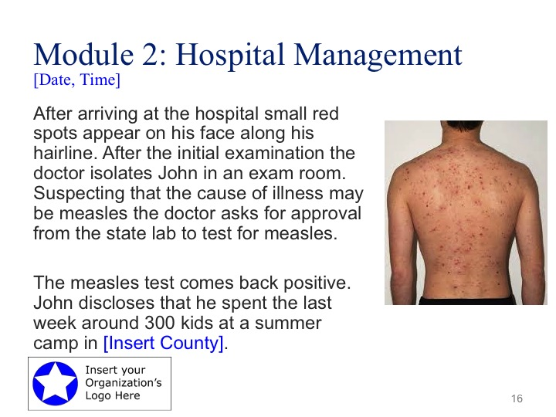

***Instructors Note: Reference the form used to request infectious disease sampling for measles.***

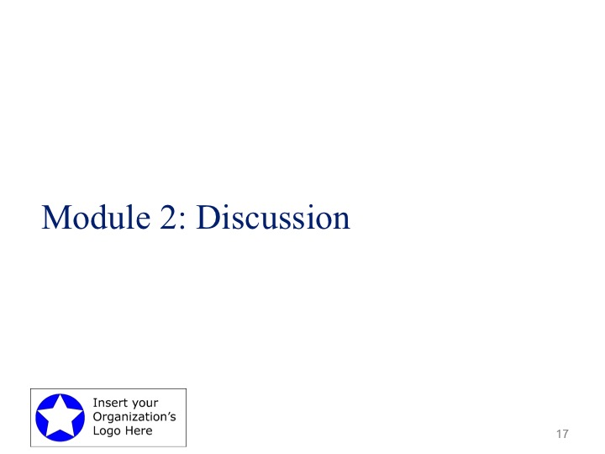

**Suggested Questions:**

**EMS**

1. Who is responsible for informing the EMS crew that the patient presented with measles?
2. What are your policies and procedures for screening, isolation, medical consultation, and monitoring and management of EMS personnel who may have been exposure to an infectious disease and/or illness?
3. What is the process for disinfecting the ambulance, equipment and crew following the transport of the patient for this disease? Who communicates this to the responding crew?
4. What if any are the procedures for disposing of waste material generated by caring for and transporting a patient with this disease?

**Hospital**

1. Would this trigger the activation of the hospital’s emergency response plan?
2. Who is responsible for reporting this and to who would this reported to?
3. What actions would the hospital take in response to this situation?
4. What special precautions will be in place for hospital staff assigned to treat the patient?
5. Are there any expectations from the Healthcare Coalition at this time?

**Virginia Department of Health**

1. What initial actions would VDH take at this time?
2. How is the risk to the children at the camp and other people that the patient interacted with mitigated?
3. Would this result in a public health declaration? What conditions would determine this?
4. What are your expectations of the Healthcare Coalition at this point?
5. Do you have enough staff to manage the contact tracing for this event?
6. Would POD operations be considered for this incident?

**Emergency Management**

1. How is the local EM office coordinating with the Health District to determine appropriate protective actions for responders?
2. What policies and procedures will minimize first responder exposure? How is this information being shared with first responders?
3. How is messaging being coordinated locally and/or regionally and statewide? Would a JIC stand up for this type of incident?

## Supplemental Questions

**EMS**

1. How would the ambulance and transport vehicles be cleaned after responders learn it was a positive measles case?
2. What resources would be requested from hospital personnel?

**Hospitals**

1. How soon after the patient tests positive for measles is the health department notified?
2. Do you accept verbal reports of vaccinations?
3. How many days should the patient be isolated?
4. Describe the respiratory etiquette and airborne precautions at the hospital.

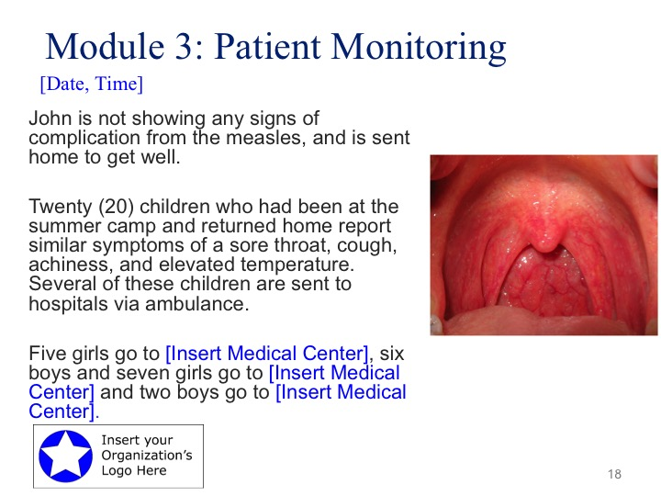



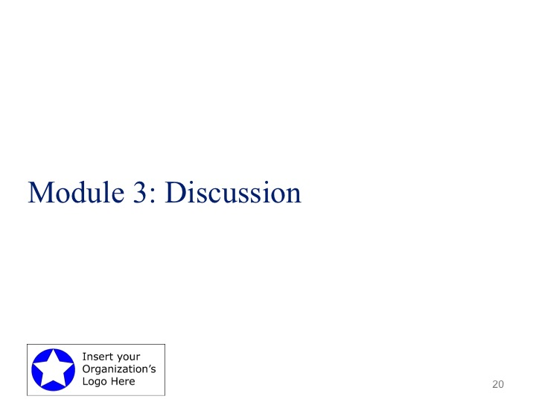

***Instructors Note: Need to focus on the fact that children from the camp are unaware of the outbreak and have left to go back to their homes all across the state.***

**Suggested Questions:**

**911 Dispatch or Emergency Medical Dispatch**

1. Would dispatchers be instructed to include additional screening questions?

**EMS**

1. Are there protocols in place for the transport of suspected measles cases? If so, does it take into consideration transportation of family members in suspect infectious disease cases?
2. Are their any changes to PPE protocols in response to this situation?
3. What protocols are in place to ensure vaccine status of workers? Who is responsible for reviewing these records? To whom, would you report the vaccination status of workers?

**Hospital**

1. Do the hospitals have the capacity to handle this many measles cases?
2. Would this trigger the activation of the hospital’s emergency response plan?
3. What special precautions will be in place for hospital staff assigned to treat patients?
4. What type of information would be shared with partners such as the Healthcare Coalition at this time?
5. What protocols are in place to ensure vaccine status of workers? Who is responsible for reviewing these records? To whom, would you report the vaccination status of workers?

**Virginia Department of Health**

1. How will VDH contact children’s families who attended the summer camp? Does VDH have the staffing needed to accomplish this?
2. Does the local department have a social media policy allowing them to post updates on their social media channels?
3. How will VDH help contain the rumor mill on social media and with the public?
4. Given that many of the children at the camp are not vaccinated how will this impact response to the incident?
5. Is this now a public health emergency?
6. What are the initial priorities and actions now that more patients are admitted to the hospital?

**Emergency Management**

1. Would the EOC stand up at this point in the outbreak?
2. What resources can emergency management provide to assist with dealing with this outbreak?
3. What are the information needs of emergency management at this time?
4. What resource assets would emergency management help manage?
5. Would a recommendation for a local emergency declaration be made at this time?
6. Would a local or regional JIC be stood up at this point?

## Supplemental Questions

**EMS**

1. What is the process for notifying other patients who many have been transported in contaminated units?
2. What resources are available that can be used for PPE in the rescue unit? How will first responders be protected from persons with measles?
3. How will the ambulance be decontaminated or will it be taken out of service?

**Hospitals**

1. Will your infection control precautions or triage process change?
2. How will the hospital acquire additional PPE and other critical resources? Does the hospital have an airborne isolation room?
3. How has the hospital been decontaminated?
4. Will hospital staff providing direct care to the confirmed cases be authorized to use public transportation? How will other work duties need to be changed for those providing direct care?

**Virginia Department of Health**

1. What roles will other healthcare organizations, such as pharmacies, medical equipment, behavior health and long-term healthcare facilities play? Will your services be impacted? What resources can you provide to the hospital and/or the public?
2. How will local, regional and state public health authorities coordinate and work with each other and the hospital to get needed information from the hospital? Is staff prepared to work effectively in the field (staff availability, documentation of immunity, PPE)?
3. Would the situation warrant opening a Point of Dispensing (POD) or equivalent to administer MMR vaccine?
4. How would monitoring of close contacts outside the hospital be accomplished? Would isolation or quarantine orders be considered for the hospitalized patients or their contacts? If so, how would those be issued and enforced?
5. How will communication with other healthcare providers in the region be conducted? What will be the messages for other hospitals? Who will coordinate with other county and discipline members of the Northeast Florida Healthcare Coalition?
6. How is epidemiology staff communicating with the hospital staff? Will the epidemiologists be required to monitor all of the hospital and first responder staff?

**Virginia Department of Behavioral Health and Developmental Studies**

1. What considerations have you given to the potential behavioral health impact on the patient, his family, and individuals vicariously affected?
2. What are the added stresses put on hospital staff while monitoring the patient? Are there any plans, policies, or procedures to mitigate these stresses?
3. With regard to stresses associated with a possible life-threatening infectious, what community-based behavior health resources are available to assist:
4. Is your local Community Service Board (CSB) integrated into preparedness and response plans for an infectious disease outbreak?
5. In the case of larger public disease exposure, what steps plans, policies, and procedures are in place to avoid panic and mitigate stress in the general public?

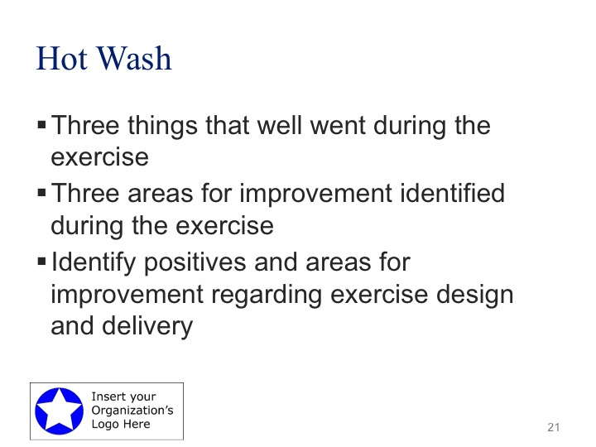

This is an opportunity for players to discuss any unresolved issues that have arisen during exercise play.

The Hot Wash is an important part of the exercise process. This is an opportunity for players to discuss what they felt were the “highs and lows” of the discussion. Ask players to give their opinion on what aspects of the discussed response went well, and what can be improved, based on their agencies role in the response. This is not the time for problem solving; ask players for potential areas for improvement and move on. Using a “three up, three down” format for sharing insights from the exercise is effective. The evaluators should gather the information discussed during the Hot wash as a part of the information to be included in the After-Action Report.



Thank participants for attending.

# Appendix A: Exercise Schedule

X:XX am – X:XX am Registration

X:XX am – X:XX am Welcome and Overview of Objectives

* Welcome by [insert agency]
* Introductions
* Ground rules and safety procedures
* Agenda and material review
* Review of TTX Objectives

X:XX am – X:XX am Module 1: Incident Notification and Transport

* Scenario Briefing
* Discussion

X:XX am – X:XX am Break

X:XX am – X:XX am Module 2: Hospital Management

* Scenario Briefing
* Discussion

X:XX pm – X:XX pm Lunch

X:XX pm – X:XX pm Module 3: Patient Monitoring

* Scenario Briefing
* Discussion

X:XX pm – X:XX pm Hot Wash and Conclusion

# Appendix B: Records and Forms

The following records and forms are provided for your use during the exercise:

* **Notes - Personal Response Roles**—During the exercise, you may identify issues that impede your job or opportunities that may improve your role as a responder. This form will not be submitted to the exercise staff, but will be a document for you to take back to your jobs.
* **Action Item Workplan**—The TTX Hot Wash session will discuss issues that were identified earlier in the exercise. This form will help you to track issues for further discussion during the exercise. You will not be asked to turn in this form, but you may raise issues during the Hot Wash session and may refer to your notes.
* **Participant Post-Exercise Feedback Form**—Participants will be asked to provide their evaluations of the TTX in the feedback form, which should be submitted prior to leaving the event. Participant input will help to improve future exercises.
* **Issue Cards**—A participant may use issue cards to raise a question, concern or issue related to the topics of discussion, but would like to remain anonymous, does not feel comfortable asking a question aloud, or the schedule did not provide enough time for further discussion.

**Measles Self-Administered TTX**

## Notes – Personal Response Roles

*Throughout the discussion, use this form to identify issues and needs that require resolution so you may effectively perform your personal response roles.*

**What additional concepts or procedures do I need clarified?**

1. __________________________________________________________________________________________________________________________________________________________________________
2. __________________________________________________________________________________________________________________________________________________________________________
3. __________________________________________________________________________________________________________________________________________________________________________

Other: _________________________________________________________________________________________

__________________________________________________________________________________________

**What changes or additions to existing plans or procedures are necessary to support or clarify my personal role?**

1. __________________________________________________________________________________________________________________________________________________________________________
2. __________________________________________________________________________________________________________________________________________________________________________
3. __________________________________________________________________________________________________________________________________________________________________________

Other: _________________________________________________________________________________________

__________________________________________________________________________________________

**What additional briefings or formal training do I need?**

1. __________________________________________________________________________________________________________________________________________________________________________
2. __________________________________________________________________________________________________________________________________________________________________________
3. __________________________________________________________________________________________________________________________________________________________________________

Other:

_____________________________________________________________________________________________

_____________________________________________________________________________________________

**What equipment, information resources, space, or support staff are needed to support my personal responsibilities?**

1. __________________________________________________________________________________________________________________________________________________________________________
2. __________________________________________________________________________________________________________________________________________________________________________
3. __________________________________________________________________________________________________________________________________________________________________________

Other: ____________________________________________________________________________________________

___________________________________________________________________________________________

|  |  |  |
| --- | --- | --- |
| **Measles Self-Administered TTX**  **[EXERCISE DATE]** Action Item Work Plan | | |
| **ACTION** | **RESPONSIBILITY** | **TIME FRAME** |
| **1.** |  |  |
| **2.** |  |  |
| **3.** |  |  |
| **4.** |  |  |
| **5.** |  |  |
| **6.** |  |  |
| **7.** |  |  |
| **8.** |  |  |
| **9.** |  |  |
| **10.** |  |  |

**Measles Self-Administered TTX**

## Participant Feedback Form

Thank you for participating in this exercise. Any comments provided will be treated in a sensitive manner and all personal information will remain confidential. Please keep comments concise, specific, and constructive.

## Part I: General Information

Please enter your responses in the form field or check box after the appropriate selection.

Name:

Agency/Organization Affiliation:

Position Title:

## Part II: Exercise Design

Please rate, on a scale of 1 to 5, your overall assessment of the exercise relative to the statements provided, with 1 indicating strong disagreement and 5 indicating strong agreement.

| **Assessment Factor** | **Strongly**  **Disagree** | | | **Strongly Agree** | | |
| --- | --- | --- | --- | --- | --- | --- |
| Pre-exercise briefings were informative and provided the necessary information for my role in the exercise. | 1 | 2 | 3 | | 4 | 5 |
| The exercise scenario was plausible and realistic. | 1 | 2 | 3 | | 4 | 5 |
| Exercise participants included the right people in terms of level and mix of disciplines. | 1 | 2 | 3 | | 4 | 5 |
| Participants were actively involved in the exercise. | 1 | 2 | 3 | | 4 | 5 |
| Exercise participation was appropriate for someone in my field with my level of experience/training. | 1 | 2 | 3 | | 4 | 5 |
| The exercise increased my understanding about and familiarity with the capabilities and resources of other participating organizations. | 1 | 2 | 3 | | 4 | 5 |
| The exercise provided the opportunity to address significant decisions in support of critical mission areas. | 1 | 2 | 3 | | 4 | 5 |
| After this exercise, I am better prepared to deal with the capabilities and hazards addressed. | 1 | 2 | 3 | | 4 | 5 |

## Part III: Participant Feedback

1. **I observed the following strengths during this exercise (please select the corresponding capability and applicable element related to the strength):**

| **Strengths** |
| --- |
|  |
|  |
|  |

1. **I observed the following areas for improvement during this exercise (please select the corresponding capability and applicable element related to the area for improvement):**

| **Areas for Improvement** |
| --- |
|  |
|  |
|  |

1. **What specific training opportunities helped you (or could have helped you) prepare for this exercise? Please provide specific course names if applicable.**

| **Training** | **Completed Prior to Exercise? (Y/N)** |
| --- | --- |
|  |  |
|  |  |
|  |  |
|  |  |
|  |  |

1. **Which exercise materials were most useful? Please identify any additional materials or resources that would be useful.**
2. **Please provide any recommendations on how this exercise or future exercises could be improved or enhanced.**

**Measles Self-Administered TTX**

## Issue Cards

Issue Card

This Issue Card is provided for you to present any issue you would like raised during the tabletop exercise. Please fill out the card and hand it to one of the exercise staff.

**Topic:**

**Issue:**

**Recommendation:**

Issue Card

This Issue Card is provided for you to present any issue you would like raised during the tabletop exercise. Please fill out the card and hand it to one of the exercise staff.

**Topic:**

**Issue:**

**Recommendation:**

# Appendix C: Acronyms

|  |  |
| --- | --- |
| AAM | After Action Meeting |
| AAR | After Action Report |
| DHS | Department of Homeland Security |
| EEG | Exercise Evaluation Guide |
| FEMA | Federal Emergency Management Agency |
| HSEEP | Homeland Security Exercise Evaluation Program |
| IP | Improvement Plan |
| IPC | Improvement Planning Meeting |
| NEP | National Exercise Program |
| NPG | National Preparedness Goal |
| SitMan | Situation Manual |
| SMEs | Subject Matter Experts |
| TTX | Tabletop Exercise |
| VDEM | Virginia Department of Emergency Management |

# Appendix D: Exercise Evaluation Guides